Go to: <https://exxat.com/>

Click on Client Login (top right of screen)

For username or email, use your [asurite@asu.edu](mailto:asurite@asu.edu)

Once you Enter or Tab, you will be promoted to click “Arizona State University created by your IT department”

Click this and it will prompt you to login with your ASUrite and password

Once logged in, you should see this screen:

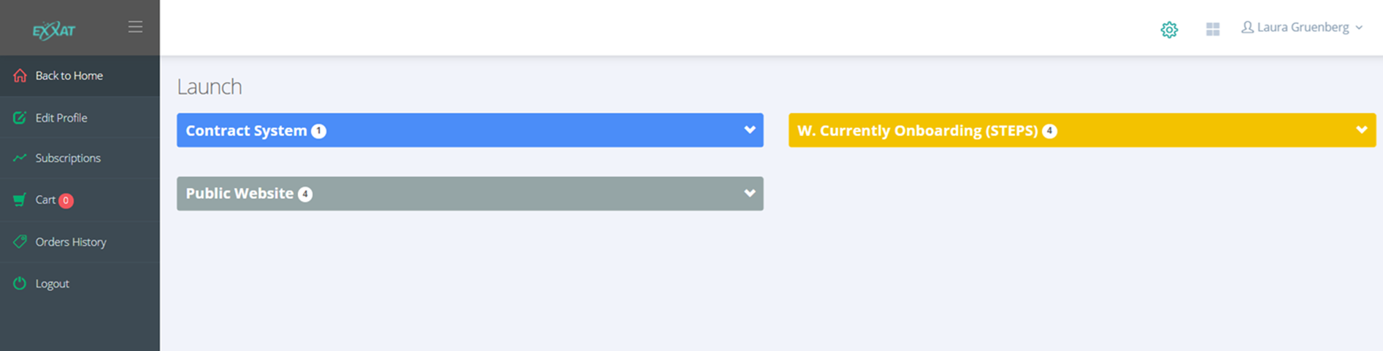

Click on Contract System

Click on ASU-CCS

Then you should see something that looks like this:

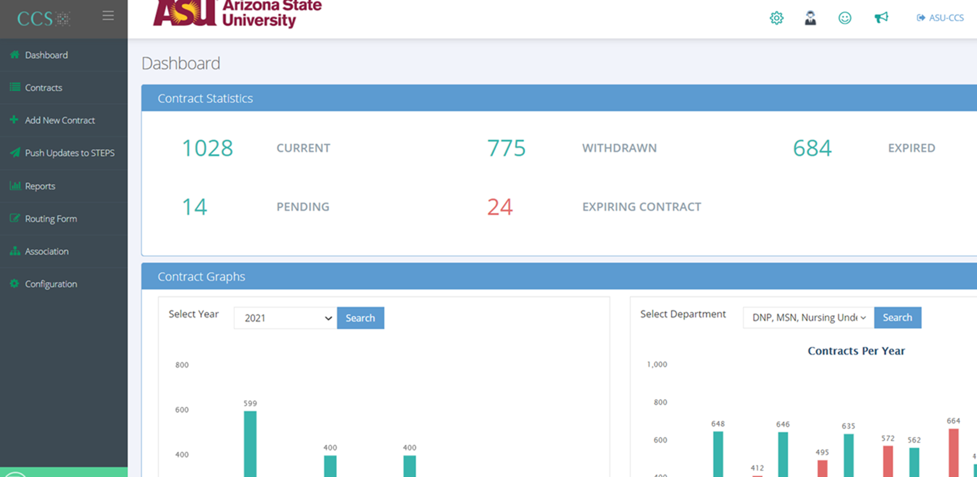

Search for Contracts by clicking Contracts on the left hand menu

Search by facility name using the Contract Company box, but change the dropdown to “Contains” instead of “Starts With”

Once you find an agreement and click on it, you should find the information you need on the top bar:



If you need further assistance, please use the following resources:

EXXAT Forum: <https://exxat.my.site.com/Forum/s/>

EXXAT YouTube Channel: <https://www.youtube.com/@Exxat>

EXXAT Support: [support@exxat.com](mailto:support@exxat.com)